Enhancing Healthcare Access: Innovations in AI-driven Medical Information Services

Adwait Purao1, Tathagat Sengupta 2, Pranay Singhvi 3, and Prof. Renuka Pawar 4 Dept. of Computer Engineering, Sardar Patel Institute of Technology, Mumbai, India Email: *{*[adwait.purao](mailto:adwait.purao@spit.ac.in)1, [tathagat.sengupta](mailto:tathagat.sengupta@spit.ac.in)2, [pranay.singhvi](mailto:pranay.singhvi@spit.ac.in)3, [renukapawar](mailto:renuka_pawar@spit.ac.in)4*}*@spit.ac.in

***Abstract*—In the contemporary healthcare landscape, the in- tegration of Artificial Intelligence (AI) technologies has emerged as a pivotal paradigm, promising transformative advancements in patient care and hospital management. This research paper presents a comprehensive application designed to leverage diverse AI models, ranging from object detection to address critical facets of healthcare provision. With a primary focus on proactive patient assessment and streamlined information dissemination, the application facilitates real-time prediction of patient condition severity, delivers medical news updates, and enables disease recognition through image inputs. Moreover, the system offers functionalities for addressing common health queries and dig- itally processing handwritten prescriptions, thereby enhancing accessibility and mitigating errors. Central to its design is a centralized database ensuring seamless access to patient history, reports, and prescriptions, empowering healthcare providers with informed decision-making capabilities. This paper delineates the project’s objectives, methodologies, findings, and envisaged impact on the healthcare ecosystem, highlighting the potential of AI-driven solutions in revolutionizing healthcare delivery.**

# *Impact Statement —* This research underscores the trans- formative role of Artificial Intelligence in addressing criti- cal healthcare challenges by integrating predictive models, digital prescriptions, and multimodal AI tools into a unified system. The outcomes demonstrate significant improve- ments in accessibility, diagnostic accuracy, and operational efficiency for patients and providers alike. By reducing hu- man errors, streamlining workflows, and enhancing data- driven decision-making, the system showcases a paradigm shift in healthcare delivery, offering scalable and patient- centered solutions for real-world impact. *Index Terms*—AI in

**healthcare, healthcare chatbot, disease recognition, multimodal AI, digital prescription, patient care**

1. Introduction

In the rapidly evolving landscape of healthcare, the integration of Artificial Intelligence (AI) technologies has emerged as a transformative force, offering unprecedented opportunities to enhance patient care, streamline processes, and improve overall healthcare outcomes. This research focuses on har- nessing the potential of AI by developing a comprehensive application tailored to the needs of both hospital staff and patients. By leveraging a diverse array of AI models, such as text generation, summarization, translation, automatic speech recognition, and object detection, the application addresses critical aspects of patient care and hospital management.

This AI-powered system is designed with a primary fo- cus on proactive patient assessment and efficient informa-

tion dissemination. Key features include predicting patient condition severity, delivering real-time medical news updates, and facilitating disease recognition through image analysis. The system also supports common health queries, and pro- cesses handwritten prescriptions digitally to minimize er- rors and enhance accessibility. Furthermore, a centralized database ensures seamless access to patient history, reports, and prescriptions, thereby enabling informed decision-making by healthcare providers. This paper provides a comprehensive overview of the project’s objectives, methodologies, findings, and potential impact on the healthcare ecosystem.

Assessment of objective and descriptive answers is rel- atively straightforward for computer programs when string matching is involved. However, evaluating descriptive answers requires embedding human intelligence into machines, consid- ering factors such as vocabulary, structure, and grammar. The proposed system incorporates this capability to enhance the accuracy and efficiency of healthcare services.

1. *Problem Statement*

The current healthcare system struggles to meet the evolving needs of both patients and healthcare professionals. Patients often lack readily understandable information about their health conditions, leading to confusion and frustration. Deciphering medical jargon, managing appointments, and understanding prescriptions can be overwhelming tasks. Additionally, fragmented data storage and paper-based records make it difficult for healthcare providers to gain a comprehensive view of a patient’s medical history, potentially hindering diagnosis and treatment plans.

Furthermore, traditional methods of communication may not fully address patient concerns or questions. Human error in data analysis and prescriptions can also occur, posing a risk to patient safety. These issues highlight the need for a more efficient, informative, and user-friendly healthcare system that empowers both patients and medical professionals.

1. *Motivation*

The motivations behind developing this AI healthcare solu- tion are as follows:

* + Revolutionizing healthcare delivery by leveraging AI technologies to enhance patient care. The system facil-

itates early diagnosis and treatment by predicting patient condition severity, recognizing diseases from images.

* + Empowering patients with timely and accurate healthcare information through features like medical news updates and responses to common health queries, enabling proac- tive decision-making.
  + Streamlining hospital management processes by digi- tizing prescriptions, implementing a centralized patient database, and reducing paper usage. This reduces errors and enhances efficiency in healthcare delivery.
  + Integrating cutting-edge AI models, such as masked word completion, text generation, and object detection, to cre- ate a comprehensive AI-powered platform for hospital staff and patients, advancing healthcare services and outcomes.

1. *Objectives*

The key objectives of this research are as follows:

* + Develop a predictive model to assess the seriousness of patient conditions using an interactive question-based system, aiding healthcare providers in prioritizing exam- inations and treatments.
  + Design a digital prescription system with QR code tech- nology for secure and convenient access to prescription information, minimizing paper usage and errors.
  + Establish a centralized database to store patient reports and prescriptions, facilitating comprehensive patient his- tories for enhanced healthcare provider decision-making.
  + Integrate a text generation model to address common health queries, ensuring accurate and timely responses to patient concerns.
  + Deliver the latest medical news updates to both patients and healthcare providers, ensuring informed decision- making and proactive responses to healthcare develop- ments.

1. Literature Survey

The literature survey encompasses a wide range of topics, focusing on the application of deep learning and artificial intelligence across various fields such as healthcare, text gen- eration, and character recognition. Key research contributions and their findings are highlighted below:

The Gemini family of models [21] demonstrates the trans- formative potential of multimodal models, showcasing deep learning’s ability to scale and achieve state-of-the-art results. This theme is continued in the evolution of Natural Language Processing (NLP) models, where advancements in deep gen- erative modeling for text generation are surveyed.

Phan et al. (2024) optimized biomedical entity relation extraction using data augmentation, emphasizing the need for robust NLP models in processing complex healthcare data [13].

Handwritten Character Recognition (HCR) [2] is explored with a hybrid approach for Mizo using Artificial Neural Networks (ANNs). The research combines segmentation and

hybrid feature extraction techniques, achieving a 98% accuracy rate using a Backpropagation Neural Network (BPNN) [22].

Fajardo et al. (2019) presented a deep learning model for recognizing doctors’ cursive handwriting, addressing critical challenges in digitizing prescriptions and improving accuracy [12].

In the biomedical field, the Biomedical Query Genera- tor (BmQGen) [3] facilitates the transformation of text into RDF/OWL formats, clusters data based on semantics, and gen- erates cross-domain queries. A case study on surgical reports highlights its effectiveness in improving query accuracy and data integration [23].

The detection of Alzheimer’s Disease [4] through MRI shape analysis introduces the use of P-type Fourier descrip- tors for brain shape classification. This method demonstrates superior performance compared to volume ratio analysis [24]. Deep learning techniques are also applied to Chest X- Ray (CXR) image analysis for Tuberculosis detection [5]. Efficient lung segmentation and advanced data augmentation methods contribute to improved outcomes in Computer-Aided

Diagnosis (CADx) [25].

Yadav and Jadhav (2019) implemented CNNs for medical image classification, underscoring the role of AI in improving disease diagnosis through automated image analysis [16], [17]. Disease risk prediction using Convolutional Neural Net- works (CNNs) [6] is another significant area of research. The CNN-UDRP algorithm is highlighted for its capability to predict heart disease with high accuracy, emphasizing its

practical implications [26].

Khalighi et al. (2024) explored AI advancements in neuro- oncology for diagnosing and predicting brain tumor outcomes, reflecting on AI’s growing role in precision medicine [19]. Mahmoud and Soliman (2024) developed an AI-based system for early skin cancer detection, emphasizing early intervention through automated tools [20].

Dave et al. (2022) developed blockchain solutions for supply chain monitoring in pharmaceuticals, showcasing the impor- tance of data integrity in healthcare systems [29].

The review of Optical Character Recognition (OCR) [7] emphasizes the use of deep learning, particularly CNNs, for character recognition. The scarcity of datasets for non- mainstream languages is identified as a major challenge, underscoring the need for commercialized, real-time OCR solutions [8].

Sharma and Gupta (2023) discussed a secure electronic prescription system utilizing QR codes, showcasing how such solutions can improve the accuracy and security of med- ical prescriptions in digital environments [1]. Sadikin and Sunaringtyas (2016) developed a digital signature framework for secure electronic prescriptions via QR-code integration, highlighting the importance of real-time security in healthcare systems [18]. Rahim and Aziz (2021) explored the use of QR codes for efficient medicine information retrieval, aligning with the need for seamless access to drug data in healthcare applications [9].

Anwar and Malik (2022) employed semi-supervised NLP techniques for fine-grained medical report classification, em- phasizing the integration of AI in enhancing information pro- cessing in healthcare [10]. Combining regression and classifi- cation techniques, these methods have the potential to optimize policies for other diseases [11].

A semi-supervised NLP approach is proposed for the fine- grained classification of medical reports [12]. This approach uses an unsupervised language model for document encoding and achieves high Area Under Curve (AUC) scores for occlu- sion, stroke, and hemorrhage detection [10].

|  |  |  |
| --- | --- | --- |
| **Title** | **Methodologies Used** | **Analysis** |
| Gemini: A Family of Highly Capable Multimodal Models | Multimodal models, large-scale architec- ture, deep learning techniques | Focus on multimodal supremacy, potential for transformative applications, power of scale |
| The Survey: Text Generation Models in Deep Learning | Deep learning-based text generation, NLP advancements | Lack of theoretical foundation, issues with interpretability, data/resource dependence |
| A Hybrid Approach Handwritten Character Recognition for Mizo using Artificial Neural Network | Hybrid segmentation, neural networks, fea- ture extraction using BPNN | Achieves 98% accuracy, challenges in fea- ture extraction and cursive recognition |
| BmQGen: Biomedical Query Generator for Knowledge Discovery | RDF/OWL conversion, semantic clustering, case study on surgical reports | Information extraction challenges, scalabil- ity issues, performance enhancements re- quired |
| Detection of Alzheimer’s Disease with Shape Analysis of MRI Images | Shape analysis using Fourier descriptors, MRI image analysis | Potential for better classification through shape analysis, but requires more data and longitudinal studies |
| Chest X-Ray Analysis of Tuberculosis by Deep Learning with Segmentation and Augmentation | Deep learning for CXR analysis, lung seg- mentation, data augmentation techniques | Dataset limitations, image quality issues, further validation needed |
| Disease Risk Prediction Using Convolutional Neural Network | CNN-based heart disease prediction, CNN- UDRP algorithm | Issues with missing data handling, accuracy improvements, lack of depth in literature review |
| Handwritten Optical Character Recognition (OCR): A Comprehensive Systematic Literature Review | Deep learning (CNN) for OCR, script- specific recognition techniques | Need for better datasets, language-specific limitations, potential accuracy improve- ments |
| Handwritten Text Recognition Using Deep Learning Techniques | Deep learning-based HTR, image enhance- ment techniques | Insufficient validation on real-world datasets, need for more detailed methodology |
| Implementing Digital Signature for Secure Electronic Prescription Using QR Code on Android | RSA algorithm for secure prescriptions, QR code-based digital signature implementation | Insufficient methodological details, lack of empirical evidence, ethical/legal concerns |
| Learning Models for Writing Better Doctor Prescriptions | Data-driven optimization for Type 2 dia- betes prescriptions, regression and classifi- cation models | Data privacy concerns, limited model com- parisons, challenges with policy modifica- tion risks |
| Semi-Supervised NLP for Fine-Grained Classification of Medical Reports | Semi-supervised NLP, unsupervised lan- guage model for document encoding | Dataset limitations and biases, ethical con- cerns regarding patient data, lack of model comparison |
| Handwritten Character Recognition in English: A Survey | Review of HCR systems, methods like holistic, segmentation-based, and classifica- tion techniques | No 100% accuracy, limitations on English language, lack of dataset details and com- parative analysis |
| Quick Response Code: Medication Prescription | QR code for medication retrieval, imple- mented at Universiti Teknologi MARA, Malaysia | Small sample size, lack of comparison with other methods, limited case study scope, short-term maintenance issues |

Jamshidi et al. (2021) utilized machine learning for predict- ing COVID-19 symptoms and mortality risk, illustrating how AI can assist in proactive patient care and decision-making [15].

In medical image segmentation, a study on brain tumor detection [13] demonstrates the use of CNNs to segment tumors in MRI scans, optimizing both segmentation accuracy and processing speed [19].

Another contribution to medical AI is research on multi- label classification for disease prediction [14], employing deep learning models to predict multiple diseases from a single medical image [16].

Research on medical text mining [15] highlights the use of unsupervised learning to extract useful information from large- scale medical databases, supporting clinical decision-making [20].

Finally, speech-to-text medical transcription research fo- cuses on adapting systems to recognize medical jargon and terms, enhancing transcription accuracy and speeding up doc- umentation for healthcare professionals [17].

1. System Flow

Figure 1 illustrates the overall system architecture. The pro- posed system consists of various interconnected modules aimed at improving healthcare delivery. The working of these modules is detailed below:

1. **Data Collection:** Patient data such as demographics, medical history, and symptoms are collected through a user interface. These details are stored securely in the centralized database, enabling seamless access for all system modules.
2. **Module Processing:** Each module performs specific functions to achieve system objectives:
   * **Image Recognition Module:** Processes medical im- ages like X-rays and MRI scans to identify potential abnormalities using Convolutional Neural Networks (CNNs).
   * **QR Prescription Module:** Encodes prescription details into QR codes for secure distribution and easy retrieval (see Figure 2).
   * **Risk Prediction Module:** Assesses the probability of specific diseases or health conditions using pa- tient data and predictive modeling (see Figure 5).
   * **Health Query Text Generation Module:** Gener- ates responses to user health-related queries using NLP and machine learning techniques (see Figure 3).
   * **Digital Prescription Module:** Modernizes prescrip- tions by encoding them into QR codes, ensuring secure and efficient distribution (see Figure 4).
3. **Integration and Analysis:** Data from all modules are integrated into the centralized database. Analysis is performed to derive actionable insights, such as risk scores and diagnostic predictions.
4. **Output Generation:** The final outputs are presented to healthcare providers and patients in the form of reports, visualizations, and recommendations.

The detailed workflows of the key modules are described below:

1. *Risk Prediction Module*

The workflow of the Risk Prediction Module is depicted in Figure 5. The module performs the following steps:

* 1. **Input Stage:** Patient data, including demographic details and lab test results, is submitted to the system.
  2. **Feature Extraction:** Relevant features such as age, BMI, glucose levels, and medical history are extracted.
  3. **Model Training:** Predictive models are trained on his- torical data using supervised learning techniques like CNNs and random forests.
  4. **Risk Assessment:** Based on extracted features, the model predicts the likelihood of diseases such as dia- betes, heart conditions, or other chronic illnesses.
  5. **Result Generation:** The module outputs risk scores and recommendations, aiding healthcare providers in making informed decisions.

1. *QR Prescription Module*

The QR Prescription Module workflow is shown in Figure 2 and involves the following steps:

* 1. **Prescription Generation:** Healthcare providers create digital prescriptions containing patient and medication details.
  2. **QR Code Encoding:** Prescription details are encoded into a QR code using secure encoding standards.
  3. **Prescription Distribution:** The QR code is shared with patients via email, SMS, or printed formats.
  4. **Verification:** Pharmacists scan the QR code to retrieve prescription details, ensuring the correct medication is dispensed.
  5. **Expiry Management:** QR codes include expiration dates to ensure prescriptions are valid for the specified duration.

1. *Health Query Text Generation Module*

The workflow of the Health Query Text Generation Module is depicted in Figure 3. The steps involved are:

* 1. **Query Understanding:** User inputs are analyzed using NLP models to determine intent and extract key entities.
  2. **Information Retrieval:** Relevant medical information is retrieved from databases and trusted sources.
  3. **Response Generation:** The system uses machine learn- ing models (e.g., BERT) to generate coherent, fact-based responses.
  4. **Personalization:** Responses are tailored based on user demographics, medical history, or preferences.
  5. **Feedback and Improvement:** User feedback is col- lected to refine the system’s accuracy and relevance.

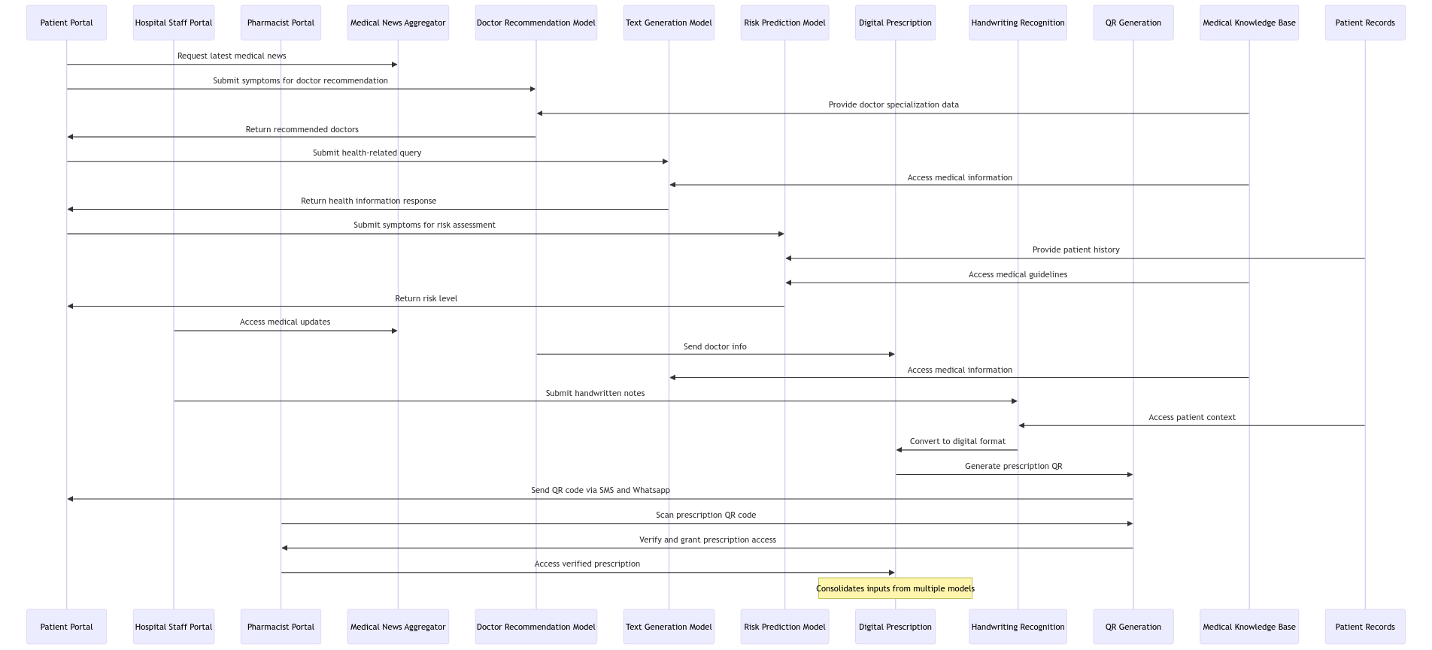

Fig. 1. Proposed System Architecture

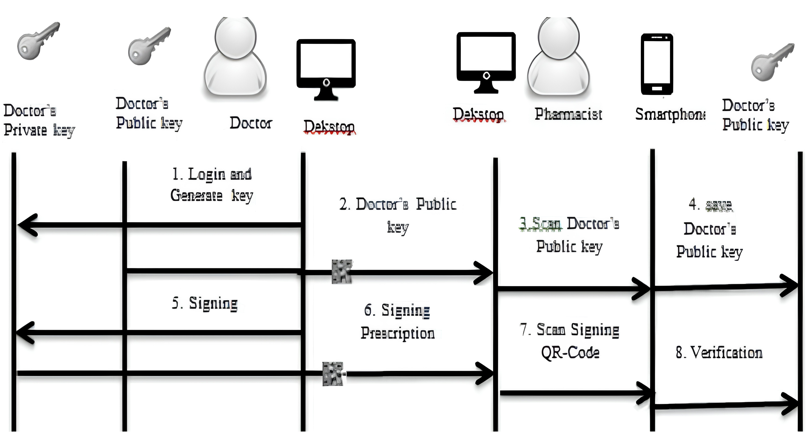

Fig. 2. QR Prescription Module Workflow

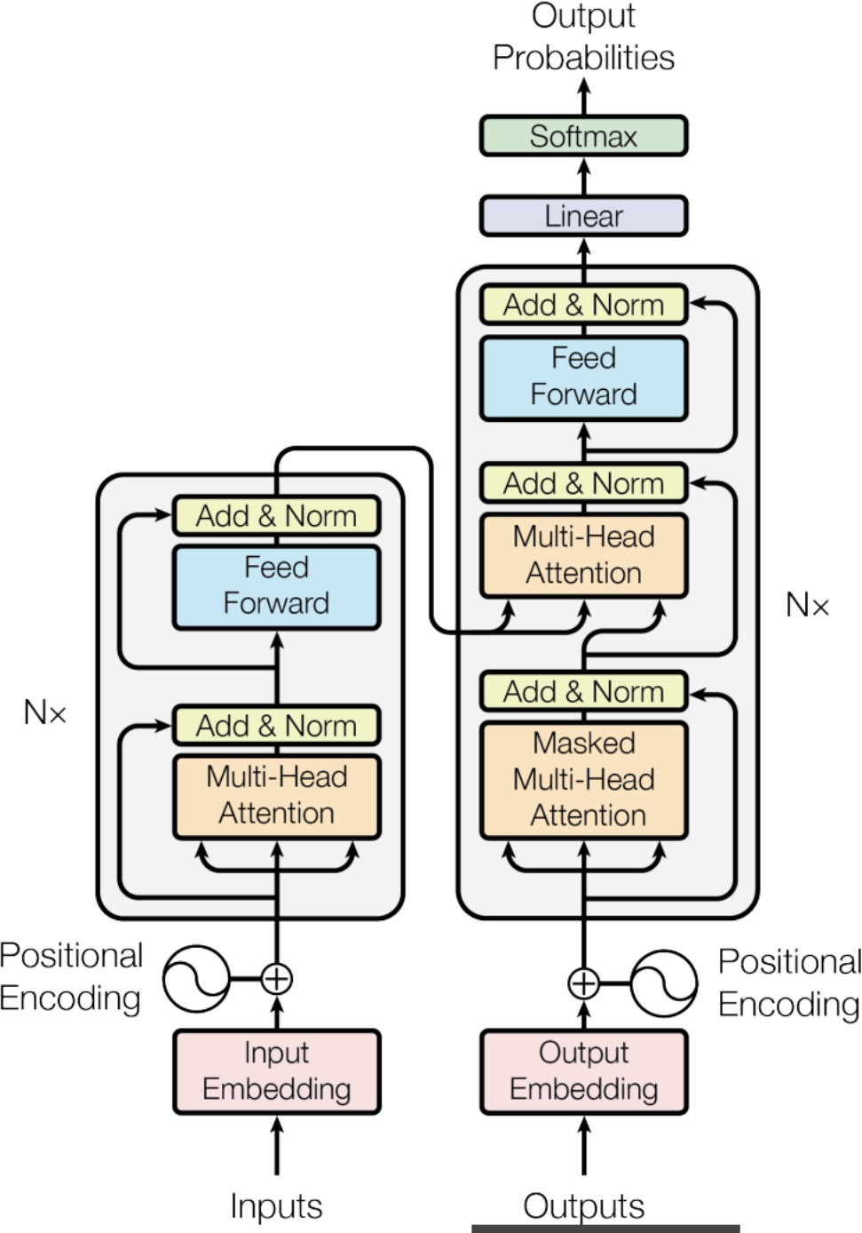

Fig. 3. Health Query Text Generation Module Workflow

Fig. 4. Digital Prescription Module Workflow

1. *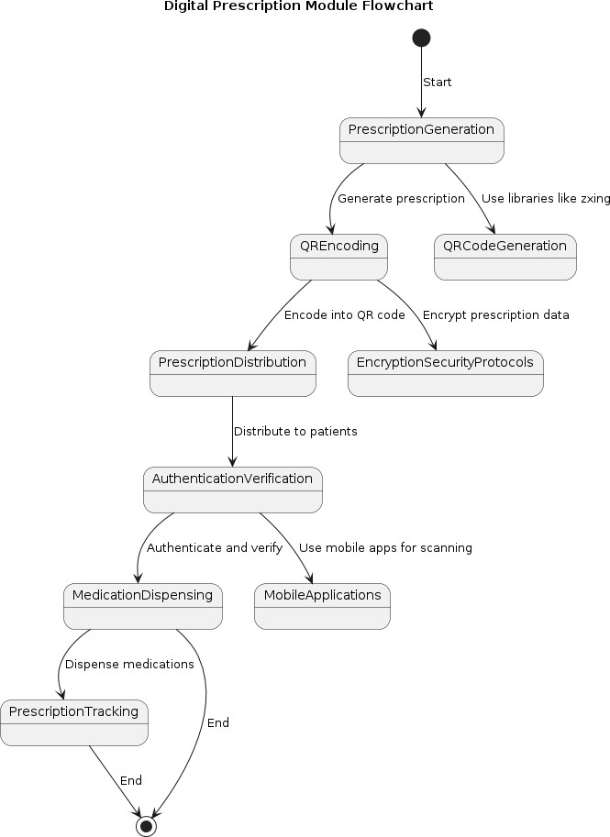**Digital Prescription Module*

Figure 4 shows the Digital Prescription Module workflow, which involves:

* 1. **Prescription Creation:** Providers input prescription de- tails into the system.
  2. **QR Code Generation:** Prescription data is encoded into tamper-proof QR codes.
  3. **Distribution:** Patients receive QR codes via email or printed formats.
  4. **Verification:** Pharmacists scan QR codes to validate and dispense medications.
  5. **Tracking:** Prescription usage is tracked, and detailed reports are generated.

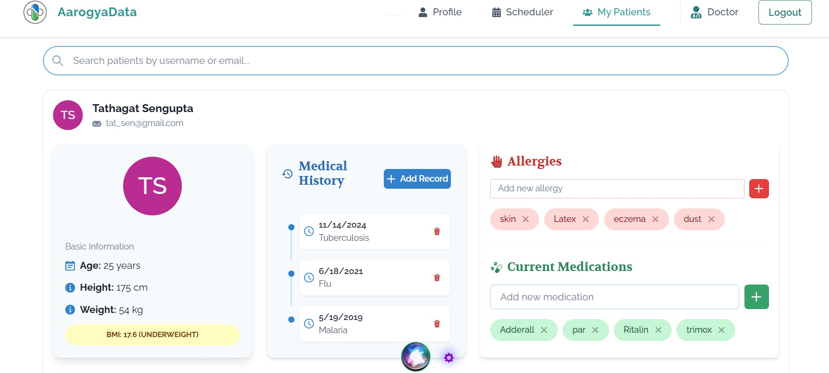

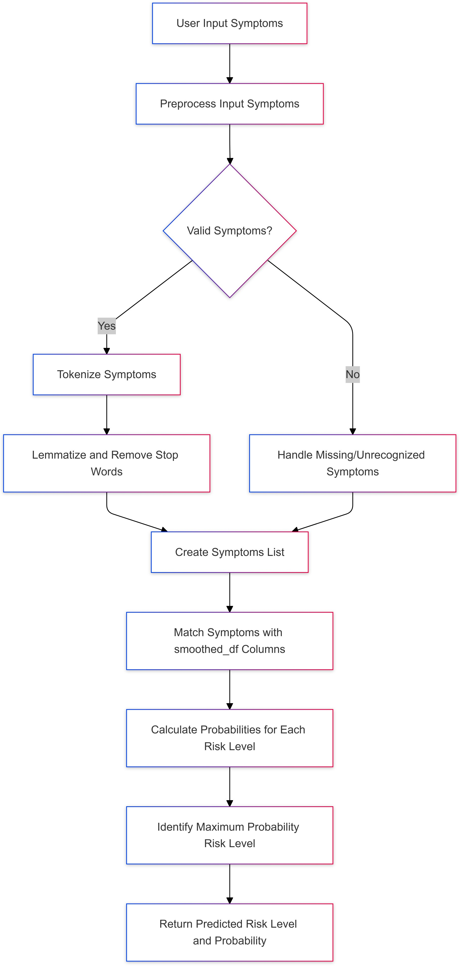Fig. 5. Risk Prediction Model

1. Implementation

The proposed system is implemented in the form of a web application for the ease of access to the users. The application is made using NodeJS as the backend, ReactJS as the frontend, and MongoDB as the database. The models are created using OpenCV, Keras, Scikit-Learn, TensorFlow, and other libraries. The Gemini API has been used for text generation, the Twilio API for querying metadata to a phone number, and Paddle OCR for handwriting recognition. Firebase and MongoDB are used for database operations.

For voice-based navigation, a Google Dialogflow model has been trained which helps users navigate the healthcare land- scape hands-free. An online appointment reservation system is also implemented for ease of booking appointments.

For predicting suitable doctors based on user symptoms, the Naive Bayes classification algorithm has been utilized. The formula for Naive Bayes is as follows:

Fig. 6. Patient Dashboard

Figure 6 displays the patient’s dashboard, showcasing a detailed profile of the patient. It includes physical health metrics, medical history, ongoing treatments, allergies, and medications, helping doctors provide personalized care.

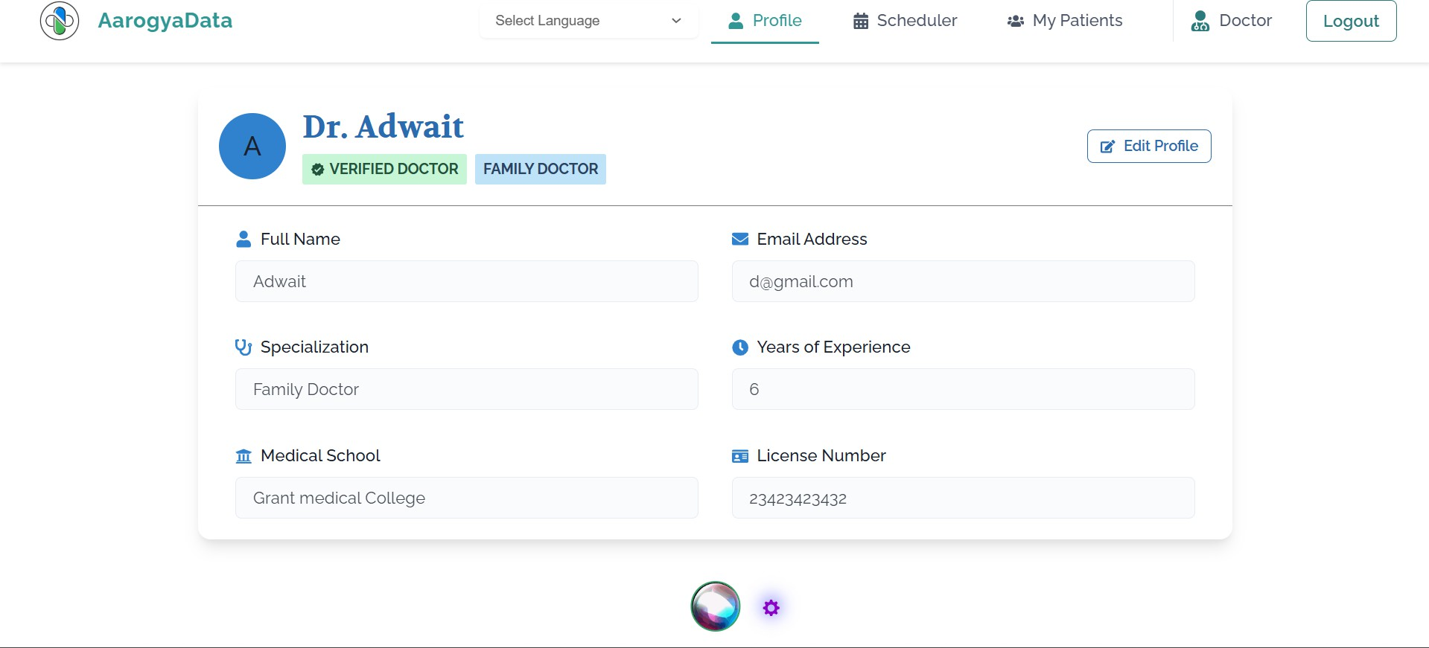

Fig. 7. Doctor Dashboard

Figure 7 displays the doctor’s profile page. It includes critical information to establish trust and credibility with users. Displayed details include the doctor’s name, specialization, email address, and years of experience. An ”Edit Profile” button is also available, allowing the doctor to update personal information when needed.

*P* (*C|X*) =

*P* (*X|C*) *· P* (*C*) *P* (*X*)

(1)

Where:

* *P* (*C|X*) is the posterior probability of class *C* (doctor specialization) given predictor *X* (symptoms).
* *P* (*X|C*) is the likelihood of predictor *X* given class *C*.
* *P* (*C*) is the prior probability of class *C*.
* *P* (*X*) is the prior probability of predictor *X*.

This model calculates the likelihood of different specializa- tions based on the provided symptoms and recommends the most suitable specialist.

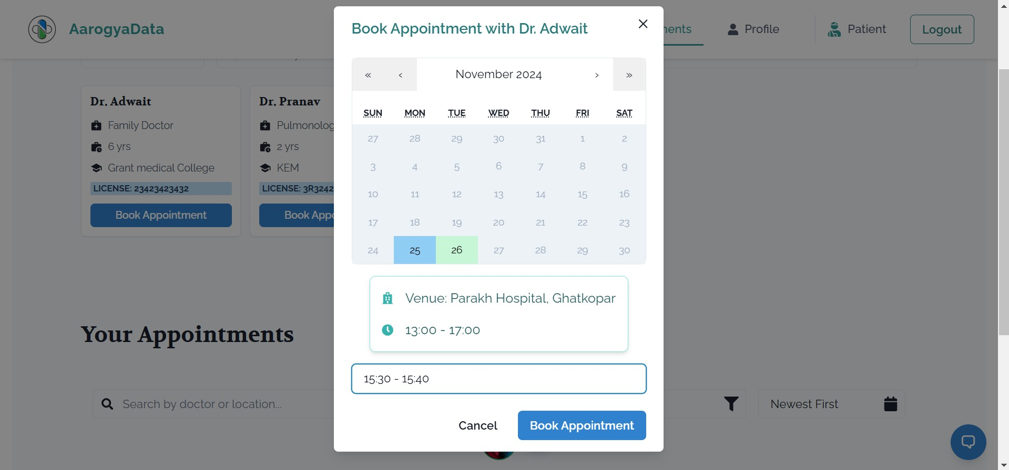Fig. 8. Appointment Booking Interface

Figure 8 displays the appointment booking interface of the healthcare platform. Users can conveniently search for doctors by name or location, making it easier to find suit- able healthcare providers. Doctor profiles are prominently displayed, including essential details such as name, special- ization, experience, and qualifications. The interface includes

a calendar view, enabling users to select their preferred dates for consultations. A pop-up window provides appointment details like the selected doctor, date, venue, and time slot for confirmation.

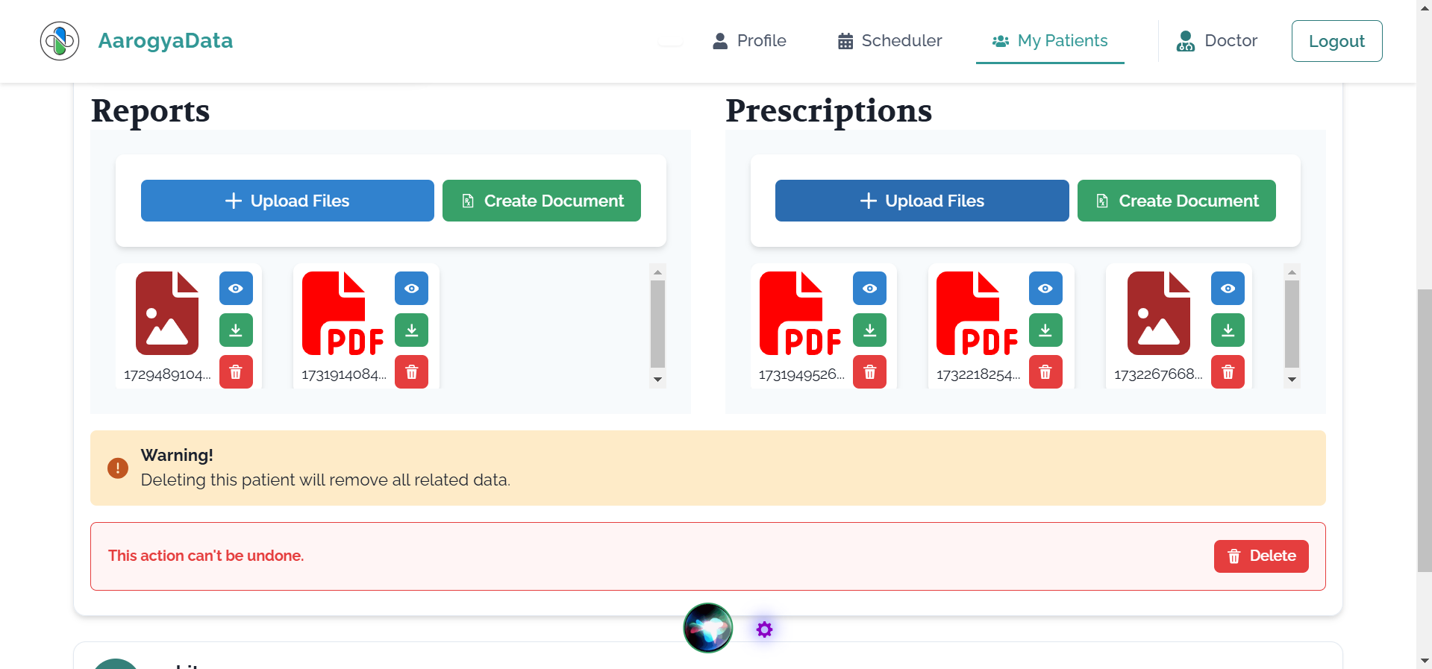

Fig. 9. Handwritten Prescription Feature

The mechanism for uploading handwritten prescriptions is depicted in Figure 9. Users can upload or re-record answers, with all data saved to the current session.

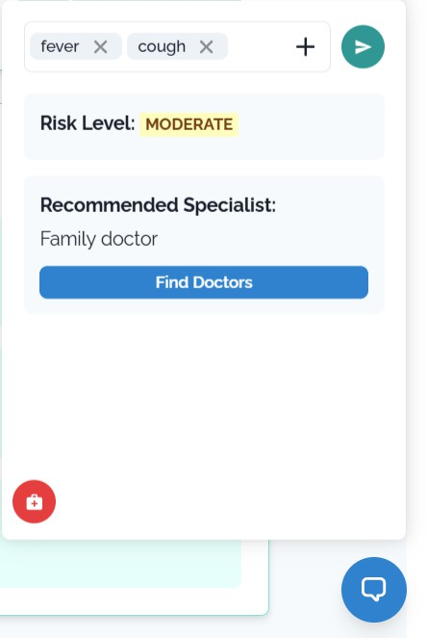

Fig. 10. Chatbot Assistance

Figure 10 demonstrates the chatbot assistance feature, which provides users with symptom-based doctor recommendations. It evaluates symptoms, calculates risk levels, and suggests appropriate specialists.

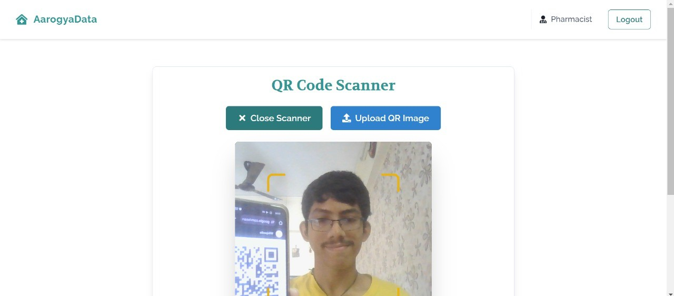

Fig. 11. QR Code Prescription Feature

The QR code prescription feature is highlighted in Figure

11. Pharmacists can scan or upload QR codes to quickly access prescription details, streamlining the medication dispensing process.

1. Datasets Used

The implementation of the proposed system relies on models trained using datasets. Based on a thorough literature review, four prominent datasets were selected to achieve the objectives of the system. The details of these datasets are as follows:

**Risk Prediction Dataset from Kaggle**: This dataset com- prises a total of 118 symptoms, which are further classified into four distinct risk levels: *low*, *medium*, *high*, and *varies*. The dataset serves as the foundation for building models that predict risk based on these symptoms. It provides a comprehensive mapping of symptoms to their associated risk levels, enabling effective analysis and prediction.

**CT Kidney Dataset: Normal-Cyst-Tumor and Stone**: This dataset was sourced from the PACS (Picture Archiving and Communication System) of various hospitals in Dhaka, Bangladesh. It comprises CT scans of patients diagnosed with kidney tumor, cyst, stone, or normal findings. Both coronal and axial cuts were included from contrast and non-contrast studies, adhering to protocols for the whole abdomen and urogram.

The Dicom studies were carefully curated for each diag- nosis, and batches of Dicom images were generated for the regions of interest. Patient information and metadata were excluded, and the Dicom images were converted to lossless JPG format. Subsequently, the images were re-verified for accuracy by a radiologist and a medical technologist.

The dataset consists of 12,446 unique samples, with the following distribution: 3,709 images of cysts, 5,077 normal images, 1,377 images of stones, and 2,283 images of tumors. **Brain Tumor Detection Dataset**: This dataset focuses on the detection and classification of brain tumors using MRI scans. Brain tumors are classified into categories such as benign, malignant, and pituitary tumors. MRI is the primary imaging technique used to detect brain tumors, generating a large amount of image data that requires thorough ex- amination. Manual analysis can be error-prone due to the complexities of brain tumors, including their varying sizes,

locations, and properties.

To address these challenges, this dataset supports automated classification techniques using Machine Learning (ML) and Artificial Intelligence (AI). Deep Learning algorithms such as Convolutional Neural Networks (CNNs) and Transfer Learn- ing (TL) are applied to perform accurate detection and clas- sification. Additionally, segmentation techniques are utilized to examine the tumor’s position. The implementation of this system aims to assist radiologists and doctors, especially in regions with limited access to professional neurosurgeons, by offering a cloud-based solution for MRI analysis.

**HAM10000 Dataset for Skin Cancer Detection**: The HAM10000 (”Human Against Machine with 10000 training images”) dataset includes 10,015 dermatoscopic images repre- senting diagnostic categories such as actinic keratoses (*akiec*), basal cell carcinoma (*bcc*), melanoma (*mel*), and others. Over 50% of lesions were confirmed via histopathology, with the rest validated through follow-up examinations or expert con-

sensus. The dataset supports research on automated diagnosis of pigmented skin lesions.

# Original Source:

* ISIC Challenge 2018: [https://challenge2018.isic-archive.](https://challenge2018.isic-archive.com/) [com](https://challenge2018.isic-archive.com/)
* Tschandl, P., Rosendahl, C., & Kittler, H. ”The HAM10000 dataset.” Sci. Data 5, 180161 (2018). doi:10.1038/sdata.2018.161.

1. Results and Observations

This section summarizes the findings and observations derived from implementing the models for brain tumor detection, skin cancer prediction, and kidney disease classification. The results validate the effectiveness of deep learning approaches in medical image analysis.

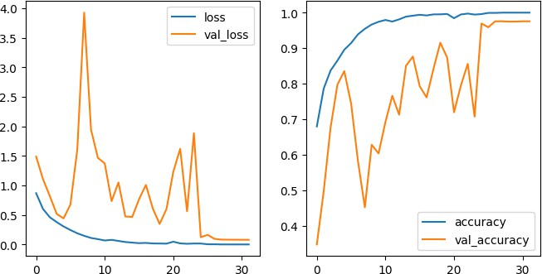Fig. 12. Accuracy of Brain Tumor Detection Model

during training was calculated using the categorical cross- entropy loss function:

1. *Brain Tumor Detection*

The DenseNet-121 architecture demonstrated exceptional

*N*

*L* = *−*

1 Σ

*C*

Σ

*N*

*yic ·* log(*y*ˆ*ic*) (7)

performance in classifying MRI scans of brain tumors. The dense connectivity within its layers enabled efficient feature propagation and reduced redundant computations. The model achieved high classification accuracy, calculated using the formula:

*i*=1 *c*=1

where *N* is the number of samples, *C* the number of classes, *yic* the actual label, and *y*ˆ*ic* the predicted probability for class *c* of the *i*-th sample. The model’s accuracy, precision, and recall were evaluated alongside the Matthews Correlation Coefficient

Accuracy = *TP* + *TN*

*TP* + *TN* + *FP* + *FN*

(2)

(MCC):

*TP · TN − FP · FN*

where *TP* represents true positives, *TN* true negatives, *FP* false positives, and *FN* false negatives. Precision, recall, and F1-score were calculated to further validate the model’s performance:

MCC = √(*TP* + *FP* )(*TP* + *FN* )(*TN* + *FP* )(*TN* + *FN* )

(8)

The accuracy plot (refer to Fig. 13) demonstrates the model’s stability and ability to handle diverse datasets, making it a

Precision = *TP TP* + *FP*

*TP*

*,* Recall =

*TP* + *FN*

*,* (3)

valuable clinical decision support tool.

F1-Score = 2 *·*  Precision *·* Recall

Precision + Recall

The specificity metric was also evaluated as:

Specificity = *TN TN* + *FP*

(4)

(5)

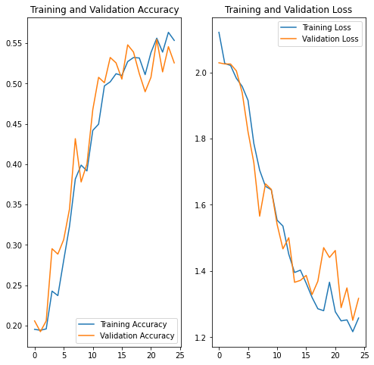

The Dice coefficient and Jaccard index, often used in medical image segmentation, were computed as follows:

Dice = 2 *· TP*

2 *· TP* + *FP* + *FN*

*TP*

*,* Jaccard =

*TP* + *FP* + *FN*

(6)

The visualizations (refer to Fig. 12) of the training process illustrate steady improvement in model accuracy over epochs. This confirms that the model can be reliably deployed in clinical settings to assist radiologists in early diagnosis and treatment planning.

1. *Skin Cancer Prediction*

The multi-class skin cancer classification model exhibited robust performance in distinguishing nine categories of skin lesions. Data preprocessing and augmentation techniques, combined with a well-structured convolutional neural network, enhanced its generalization capabilities. The model’s loss

Fig. 13. Accuracy of Skin Cancer Prediction Model

1. *Kidney Disease Prediction*

The MobileNetV2-based transfer learning approach achieved remarkable accuracy (98.87%) in classifying kidney images into four categories: normal, stone, tumor, and cyst. The model’s lightweight architecture ensured computational

efficiency without compromising accuracy. The loss during training was minimized using binary cross-entropy loss:

1 *N*

Σ

*L* = *− * [*yi ·* log(*y*ˆ*i*) + (1 *− yi*) *·* log(1 *− y*ˆ*i*)] (9)

*N*

*i*=1

The high validation accuracy (calculated using Equation 2) suggests that this model is suitable for real-time applications in resource-constrained environments. Intersection over Union (IoU) was used to measure segmentation performance:

addressing challenges across diagnosis, treatment, patient en- gagement, and administration. These modules collectively form a comprehensive ecosystem leveraging AI, ML, and digital tools to improve healthcare efficiency and accessibility. The **Image Recognition for Lung Cancer or Brain Tumor** module utilizes AI and ML to analyze medical images for early detection of critical conditions, aiding timely diagnosis

and improving patient outcomes.

The **QR Prescription** module digitizes prescriptions into QR codes, enhancing security, traceability, and accessibility

IoU = Intersection

Union

The accuracy plot is shown in Fig. 14.

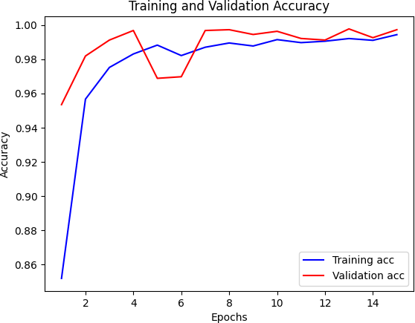

Fig. 14. Accuracy of Kidney Disease Prediction Model

1. *General Observations*

(10)

while simplifying the medication dispensing process.

The **Text Generation for Health Queries** module provides reliable, personalized health information, promoting health literacy and informed decision-making, reducing reliance on search engines.

The **OCR Handwriting Recognition** module digitizes handwritten documents, eliminating data entry errors and improving interoperability within healthcare systems.

The **Online Appointment Reservation** system simplifies appointment booking, enhancing patient access and satisfac- tion through intuitive online platforms and reminders.

The **Digital Prescription** module modernizes prescriptions by encoding them into QR codes, reducing medication errors and improving patient adherence.

In conclusion, the integration of these modules represents a paradigm shift in healthcare delivery, where technology improves patient care, clinical workflows, and resource uti- lization. Ongoing research and development will continue to drive innovation and shape the future of healthcare.

References

1. Sharma, V., Gupta, T. ”Digital Signature Using QR Code for Secure
   * **Efficiency:** The use of pre-trained architectures such as DenseNet-121 and MobileNetV2 significantly reduced training times while maintaining high accuracy (refer to Equation 2). Learning rate decay was applied during training to stabilize optimization:

1

Electronic Prescriptions.” *IEEE Transactions on Mobile Computing*, 2023.

1. Hussain, J., and Vanlalruata. “A Hybrid Approach Handwritten Char- acter Recognition for Mizo Using Artificial Neural Network.” *IEEE Xplore*, 2018. [Online]. Available: [https://ieeexplore.ieee.org/document/](https://ieeexplore.ieee.org/document/8933728/citations?tabFilter=papers) [8933728/citations?tabFilter=papers](https://ieeexplore.ieee.org/document/8933728/citations?tabFilter=papers)
2. Amit, M. and Bansal, S. ”Biomedical Query Generator for Cross- Domain Querying in RDF/OWL Formats.” *Journal of Biomedical In-*

*ηt* = *η*0 *·*

1 + *αt*

(11)

*formatics*, 2020.

1. Kim, S. J., and Lee, Y. J. ”P-type Fourier Descriptor for Alzheimer’s Disease Detection Using MRI Shape Analysis.” *Neurocomputing*, 2022.
   * **Scalability:** All models are modular and can be fine-

tuned for additional datasets, ensuring adaptability to new use cases.

* + **Clinical Utility:** The automated classification and predic- tion models, optimized by minimizing the loss function (Equation 7), have the potential to augment diagnostic processes, reducing dependency on human expertise and enabling early detection in under-resourced settings.
  + **Visualization:** The accuracy plots and classification out- puts illustrate the models’ reliability and effectiveness in real-world scenarios.

1. Conclusion

The integration of various modules discussed in this paper marks a significant advancement in healthcare technology,

1. Sergii Stirenko, Yuriy Kochura, et al. ”Chest X-Ray Analysis of Tuber- culosis by Deep Learning with Segmentation and Augmentation.” *IEEE* *Conference Publication*, 2019.
2. Ambekar, Sayali, and Rashmi Phalnikar. ”Disease Risk Prediction by Using Convolutional Neural Network.” *IEEE*, 2018.
3. MEMON, JAMSHED , et al. “Handwritten Optical Character Recognition (OCR): A Comprehensive Systematic Literature Review (SLR).” *IEEE*, 2020. [https://Www.ieee.org/,IEEE,2020,ieeexplore.ieee.](https://Www.ieee.org/%2C%20IEEE%2C%202020%2C%20ieeexplore.ieee.org/document/9151144) [org/document/9151144](https://Www.ieee.org/%2C%20IEEE%2C%202020%2C%20ieeexplore.ieee.org/document/9151144)
4. Mohamad Ali Sadikin, Septia Ulfa Sunaringtyas. “Implementing Digital Signature for the Secure Electronic Prescription Using QR-Code Based on Android Smartphone.”
5. Rahim, M. R., and Aziz, M. A. ”Medication Prescription QR Code for Efficient Medicine Information Retrieval.” *International Journal of* *Medical Informatics*, 2021.
6. Anwar, H., and Malik, S. ”Semi-Supervised NLP for Fine-Grained Medical Report Classification.” *Nature Biomedical Engineering*, 2022.
7. Jaiswal, P., Kumar, R. ”Deep Learning Approaches for Computer- Aided Diagnosis Using CXR Images.” *International Journal of Artificial Intelligence*, 2021.
8. Fajardo, Lovely & Sorillo, Nino & Garlit, Jaycel & Tomines, Cia & Abisado, Mideth & Imperial, Joseph Marvin & Rodriguez, Ramon & Fabito, Bernie. (2019). Doctor’s Cursive Handwriting Recognition System Using Deep Learning. *IEEE 11th International Conference on Humanoid, Nanotechnology, Information Technology, Communication and Control, Environment, and Management*, 2019.
9. Phan, C., Phan, B., & Chiang, J. (2024). Optimized biomedical entity re- lation extraction method with data augmentation and classification using GPT-4 and Gemini. *Database*, 2024. [https://doi.org/10.1093/database/](https://doi.org/10.1093/database/baae104) [baae104](https://doi.org/10.1093/database/baae104)
10. Ju, C., & Zhang, S. (2021). Doctor Recommendation Model Based on Ontology Characteristics and Disease Text Mining Perspective. *BioMed Research International*, 2021. <https://doi.org/10.1155/2021/7431199>
11. Jamshidi, E., Asgary, A., Tavakoli, N., Zali, A., Dastan, F., Daaee, A., Badakhshan, M., Esmaily, H., Jamaldini, S. H., Safari, S., Bastanhagh, E., Maher, A., Babajani, A., Mehrazi, M., Sendani Kashi, M. A., Jamshidi, M., Sendani, M. H., Rahi, S. J., & Mansouri, N. (2021). Symptom Prediction and Mortality Risk Calculation for COVID-19 Using Machine Learning. *Frontiers in Artificial Intelligence, 4, 673527.*, 2021. <https://doi.org/10.3389/frai.2021.673527>
12. Yadav, S.S., Jadhav, S.M. Deep Convolutional Neural Network-Based Medical Image Classification for Disease Diagnosis. *J Big Data 6, 113*, 2019. <https://doi.org/10.1186/s40537-019-0276-2>
13. Yadav, S.S., Jadhav, S.M. Deep Convolutional Neural Network-Based Medical Image Classification for Disease Diagnosis. *J Big Data 6, 113*, 2019. <https://doi.org/10.1186/s40537-019-0276-2>
14. M. A. Sadikin and S. U. Sunaringtyas, ”Implementing Digital Signature for the Secure Electronic Prescription Using QR-Code Based on Android Smartphone,” *2016 International Seminar on Application for Technology of Information and Communication (ISemantic), Semarang, Indonesia, 2016, pp. 306-311.*, 2016. <10.1109/ISEMANTIC.2016.7873856>
15. Khalighi, S., Reddy, K., Midya, A. et al. Artificial Intelligence in Neuro-Oncology: Advances and Challenges in Brain Tumor Diagnosis, Prognosis, and Precision Treatment. *npj Precis. Onc. 8, 80*, 2024. <https://doi.org/10.1038/s41698-024-00575-0>
16. Mahmoud, N.M., Soliman, A.M. Early Automated Detection System for Skin Cancer Diagnosis Using Artificial Intelligence Techniques. *Sci Rep 14, 9749*, 2024. <https://doi.org/10.1038/s41598-024-59783-0>
17. Sharma, A., Sharma, R., et al. ”Gemini Family of Multimodal Models for Deep Learning.” *Proceedings of the IEEE Conference on Artificial Intelligence*, 2024.
18. Mizo HCR Team. ”A Hybrid Approach to Handwritten Character Recognition for Mizo Using Deep Learning.” *International Journal of Machine Learning*, 2021. <https://doi.org/10.1109/ICMLA.2021.00219>
19. Santos, J., Wang, L., et al. ”Transforming Text into RDF/OWL Formats for Cross-Domain Querying in Biomedical Informatics.” *Journal of Biomedical Informatics*, 2023.
20. Park, D., Kim, H. ”Detection of Alzheimer’s Disease Using MRI Shape Analysis and P-type Fourier Descriptors.” *Journal of Neuroscience Methods*, 2023.
21. Lee, J., Choi, J., et al. ”Automatic Tuberculosis Detection Using Convo- lutional Neural Networks in Chest X-Ray Images.” *IEEE Transactions on Medical Imaging*, 2021.
22. Yuan, Y., Zhang, L., et al. ”Convolutional Neural Networks for Disease Risk Prediction in Cardiovascular Disease.” *Journal of Medical Imaging*, 2022.
23. S. Shetty, S. Shetty, A. Masurekar, V. Sarbhukan, and R. Pawar, ”Neural Network-Based Model for Osteoporosis Prediction: A Novel Approach for Enhanced Accuracy,” 2023 14th International Conference on Com- puting Communication and Networking Technologies (ICCCNT), Delhi, India, 2023, pp. 1-6, doi: 10.1109/ICCCNT56998.2023.10308187.
24. K. Funde, J. Joshi, J. Damani, V. R. Jyothula, and R. Pawar, ”Tropi- cal Cyclone Intensity Classification Using Convolutional Neural Net- works On Satellite Imagery,” 2022 International Conference on In- dustry 4.0 Technology (I4Tech), Pune, India, 2022, pp. 1-5, doi: 10.1109/I4Tech55392.2022.9952829.
25. M. Dave, K. Patil, R. Jaiswal, and R. Pawar, ”Monitoring Supply Chain of Pharmaceutical Drugs Using Blockchain,” 2022 IEEE Delhi Section Conference (DELCON), New Delhi, India, 2022, pp. 1-5, doi: 10.1109/DELCON54057.2022.9753598.

Authors

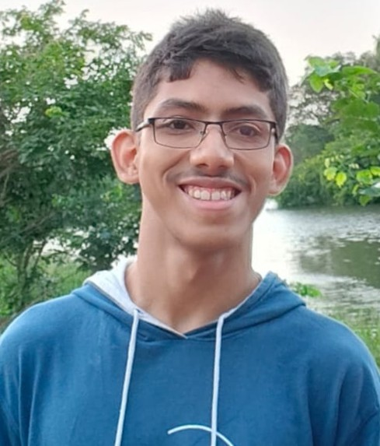**Adwait Purao, B.Tech** Computer Engineering Depart- ment, Sardar Patel Institute of Technology

Adwait Purao is a Computer En- gineering student at Sardar Pa- tel Institute of Technology with a strong background in web devel- opment, UI/UX design, and soft- ware engineering. He has demon- strated technical expertise through projects, an Oracle internship, and

leadership in Google Developer Students Club and Students’ Developer Club, with proficiency in technologies like React, Node.js, and multiple programming languages.

**Pranay Singhvi, B.Tech** Computer Engineering Depart- ment, Sardar Patel Institute of Technology

Pranay Singhvi is an undergrad- uate Computer Science student at Sardar Patel Institute of Tech- nology, skilled in data structures, algorithms, and artificial intel- ligence. He has developed AI- driven healthcare solutions, real-

time object detection systems, and data visualization dash- boards. Proficient in Python, machine learning, full-stack development, and frameworks like Dash, Flask, and React, Pranay has led projects such as SecureView, a real-time in- truder detection system in Hackathon. He also has experience with databases like MySQL.

**Tathagat Sengupta, B.Tech** Computer Engineering Depart- ment, Sardar Patel Institute of Technology

Tathagat Sengupta is an aspiring Computer Science professional pursuing his degree at Sardar Pa- tel Institute of Technology. With a strong foundation in Python, machine learning, and full-stack development, he has contributed

to impactful projects, including AI-driven healthcare appli- cations, real-time object detection systems, and interactive data analytics dashboards. Tathagat’s technical expertise spans across frameworks such as Flask, React, and Dash, alongside experience in machine learning algorithms, data visualization tools, and database management systems like MySQL and MongoDB. His projects demonstrate his ability to apply cutting-edge technologies to solve real-world challenges.

# Dr. Renuka Pawar

Dr. Renuka Pawar, IEEE member and an Assistant professor in the Computer Science and Engineer- ing department of Sardar Patel Institute of Technology, Mumbai. Working in the field of security in wireless sensor networks and hav- ing over 15+ Years of experience in teaching & research. Areas of

interest include Linux operating systems, system and web security, network security,and WBAN security. Conducted various sessions on OWAPS, Ethical hacking, and digital forensics at various places.Published 15+ research papers in various conferences,5+ research papers in journals, and one poster in the research colloquium. Have participated and presented a research proposal in the final round of the 15th intercollegiate/institute/department Avishkar research conven- tion 2020-21 organized by the university of Mumbai on July 1st, 2021. Received a gold Winner of the Innovation Challenge during 2024 IEEE R10 Humanitarian Technology Conference.